Intermediate CSS

43 The Cascade – specificity and inheritance top to bottom in the style sheet, but in line takes precedence

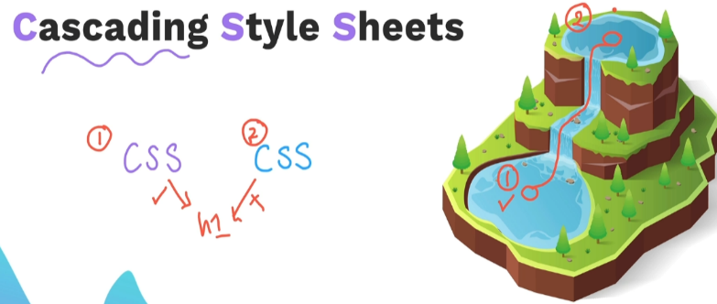

Position , Specificity , Type, Importance

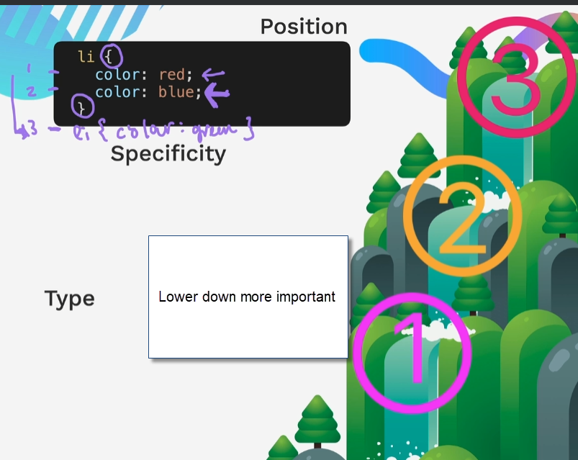

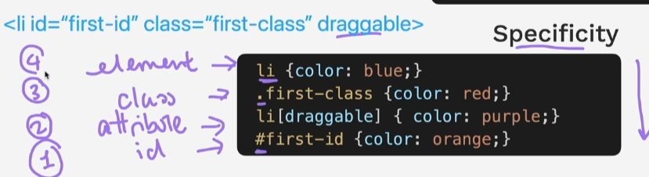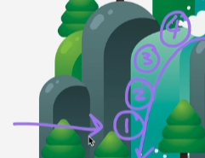

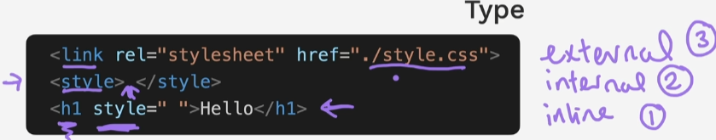

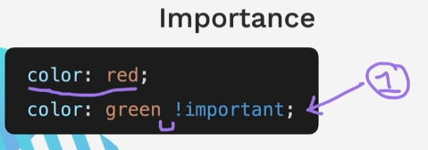

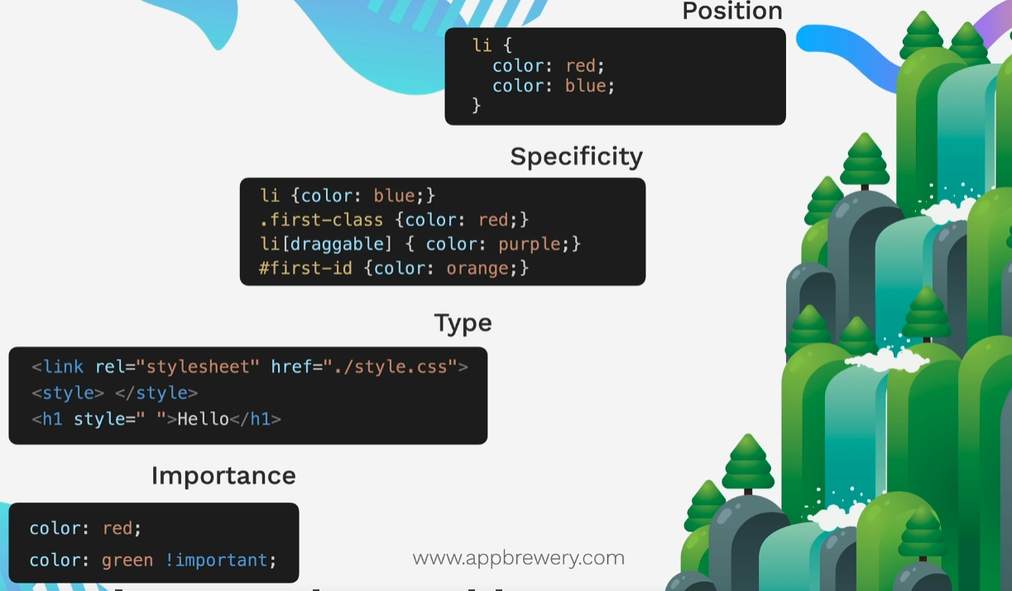

44 Combining CSS Selectors –

This rule looks to class and then descendent. Descendent is in closed by the div .

t 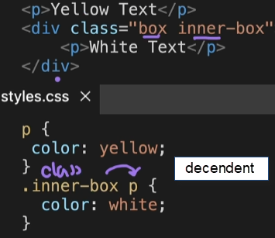

Combining CSS selectors

Group the selector followed by a comma can have several if needed CSS gets applied to all

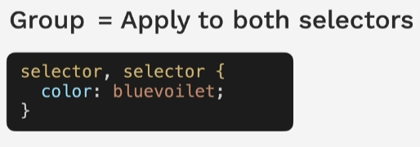

Child – child is direct descendant can only go one level down . selector seperated by angle backet

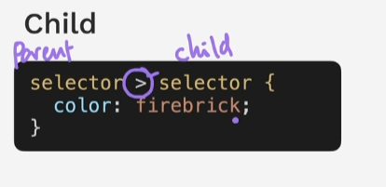

Descendant selector separated by a single space. Can go however deep needed to get to the descendent, not just one level

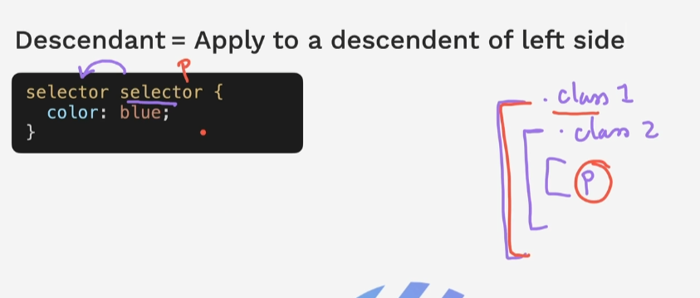

Chaining - apply where all the selectors are true to be very specific Elements start the chain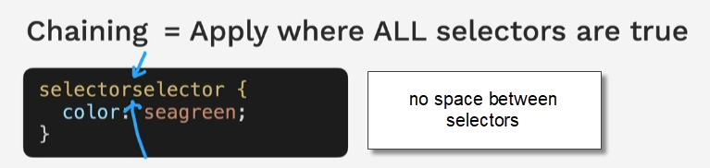



It is also possible to combine selectors

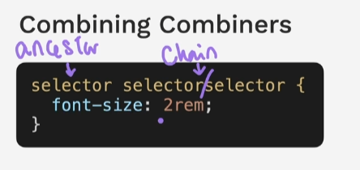

45 CSS Positioning –

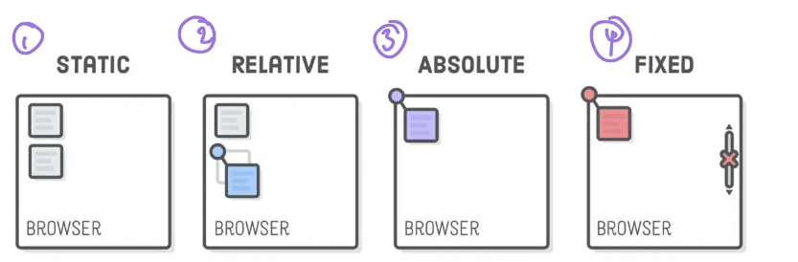

Static is the browsers default

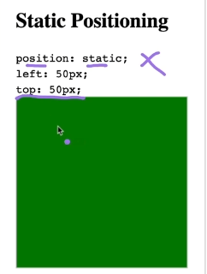

Relative Positioning

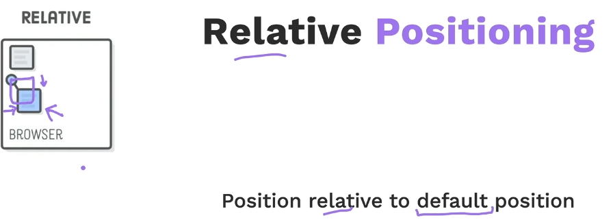

Absolute Positioning - Position relative to nearest relative positioned ancestor. If there is none then it is positioned relative to top left corner of the webpage.

Absolute positioning also takes element out of flow in terms of z index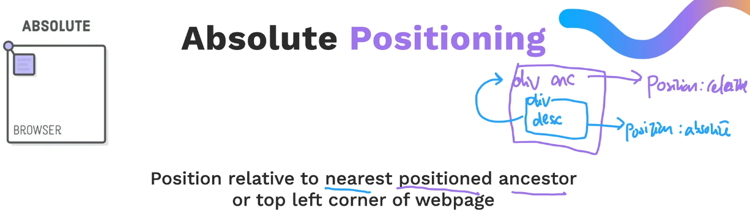

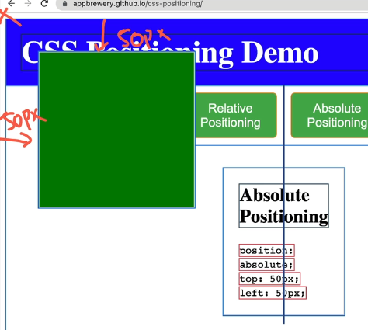

Default of z index is 0

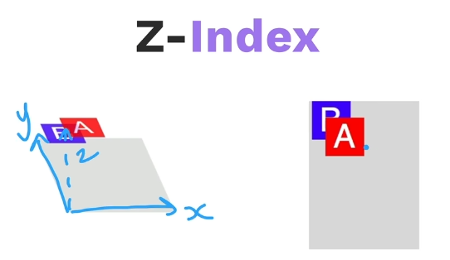

Fixed is fixed to window regardless of scrolling up or down .

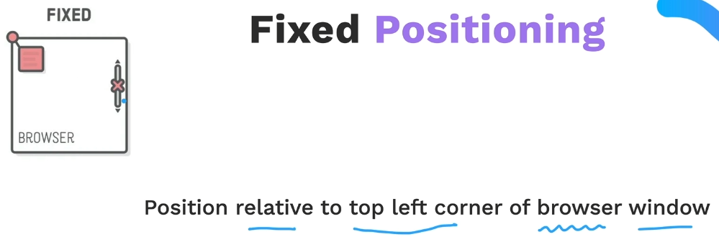

47 CSS Flag Project

All css simpons

<https://pattle.github.io/simpsons-in-css/>

Restart here

<https://www.udemy.com/course/the-complete-web-development-bootcamp/learn/lecture/37350652#overview>